8.99: The information is not sufficient to use conservation of energy. Denote the emitted neutron that moves in the 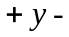direction by the subscript 1 and the emitted neutron that moves in the –y-direction by the subscript 2. Using conservation of momentum in the x- and y-directions, neglecting the common factor of the mass of neutron,

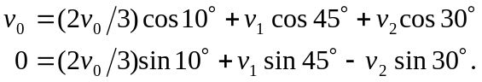

With 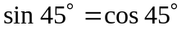, these two relations may be subtracted to eliminate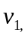 and rearrangement gives

from which 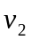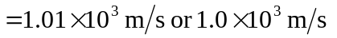to two figures. Substitution of this into either of the momentum relations gives 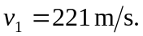 All that is known is that there is no component of momentum, and so only the ratio of the speeds can be determined. The ratio is the inverse of the ratio of the masses, so 

